1. Introduction

Church donations are a very significant part of a Church Financial Department. A church requires an accountant to keep track of all the donations. An existing system is used by the secretary to keep records of all accounts and donations. The new application is needed to be similar to the existing one but with robust features to support the needs of the secretary. The secretary will use the application to enter funds, donations, member records, and also print reports.

1.1 Purpose

The purpose of this document is to provide a detailed specification of the church financial application that is being developed. It describes the scope and the objective of the application, the type of users and the system requirements to run the application. The sequence diagram and interaction scenarios depicts the user interaction with the system. The performance and other issues corresponding to the application system are described.

1.2 Project Scope

The scope of the application is to address the problems faced by the customer using the present application. The church application currently being used lacks some features and good graphical user interface. The existing system is difficult and has many defects to use. The main function is to develop user friendly application. The user can record the donations and generate reports.

1.2.1 Main Objective

The main objective of the application is to provide a user friendly application to the church. The aim is to develop and provide the user with good GUI and more options for record keeping. The application helps the user in different ways like custom build reports for tax requirements. The records of the church members and their donations can be easily entered, modified, and deleted. The reports can be generated for different period of time.

1.3 Overview of document

In section 2, information regarding stakeholders of the project is discussed. In section 3, information regarding the project development, different features and their functionality issues are addressed, as well as the resources needed for development and the constraints. Project management, performance measures, technical and project security will be discussed. Section 4, provides information about the deliverables of the project.

2. Users

The information about the user of the system being developed is described in the section.

2.1 System Users

The church financial application is used by the church secretary. The secretary uses the application to keep records of all the donations, and generate reports.

2.2 Use Cases and Use Case Diagrams

Several use cases and their scenarios are described below

Use cases:

Use case 1: The secretary account login.

The secretary logs in to the system using the credentials.
- Secretary starts the system for the usage
- Secretary selects the fields to enter credentials
- Secretary clicks on the login or enter button.
- Secretary logs in to the system.
Extensions:
- System displays the error message and asks to correct the error.
- Contact system admin for credentials if system is locked.

Use case 2. The secretary makes record of the funds.

The secretary uses the system to record the type of funds for the church.
- Secretary selects the fund button.
- Secretary selects the function button add, update or delete.
- Secretary fills the required fields for recording the fund.
- Secretary submits the details.
Extensions:
- System failure to record, display error message.
- Component failure, display error message with options to correct it.

Use case 3. The secretary makes record of the donations.

The secretary uses the system to record the donations received.
- Secretary selects the donation button.
- Secretary selects the function button add, update or delete.
- Secretary fills the required fields for recording donations.
- Secretary submits the details.
Extensions:
- System failure to record, display error message.
- Component failure, display error message with options to correct it.

Use case 4. The secretary records the member information.

The secretary maintains member information in the system.
- Secretary selects the member button.
- Secretary selects the function button add, update or delete.
- Secretary fills the required fields for recording member.
- Secretary submits the details.
Extensions:
- System failure to record, display error message.
- Component failure, display error message with options to correct it.

Use case 5. The secretary generate reports.

The system is used to generate report for different purposes.
- Secretary selects the report button.
- Secretary fills the required fields to generate proper report.
- Secretary selects submit.
- The requested period report of the members donation is displayed.
Extensions:
- Display error message because no record exist.
- Display error message because incorrect period selected.

Use case 6. The secretary logs out from the system.

The secretary exits the system.

- Secretary selects the logout button.
- Secretary exits the system.
Extensions:
- Secretary exits the system.
- Secretary is displayed login screen for re-entry.

The figure below is a use case diagram, it shows one actor who is the user of the church donation system.

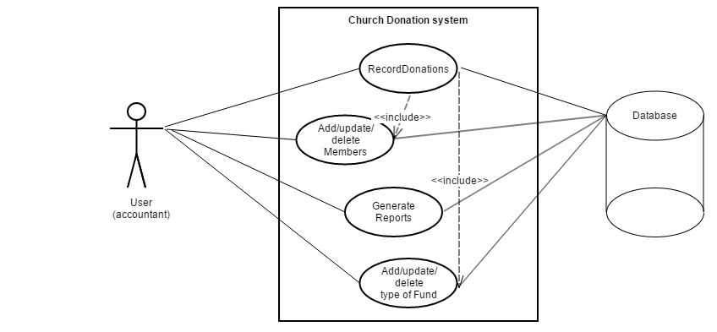

Fig 1: Use case diagram.

The diagram below is a sequence diagram, that depicts the user interaction with the system functions like adding members, generating reports.

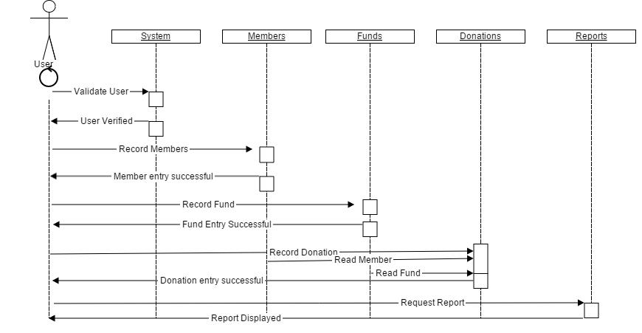
Fig 2: Sequence diagram.
3. System

This section describes the system and the applications that are used to develop the application, as well as the system and applications the user is expected to have.

The computer system used to develop the project is a computer with the latest available windows operating system because of its easy availability, is simple to use and offers easily available software.

The application developed is a web based application used in the web browser of the windows operating system like Internet Explorer.

Hardware:
Minimum requirements
Processor : Dual core
Memory Ram : 1 GB
Hard Disk : 40 GB

Software:
Development : Microsoft visual studio 2013
applications SQL Server 2008.
Operating System: Windows 7/8/8.1/10
Web browser : Internet explorer, Chrome, Mozilla Firefox.

3.1 Functional Requirements

3.1.1 Issues

This application is to be a single user software application. The application requires good security features because of the funds and the personal information in the system. Another main issue is the short amount of time for development and no budget.

3.1.2 Major Subsystems or Functions

The system has several main functions. It involves handling church member’s information, keeping proper records of donations, and generating customized reports.

The diagram below is a class diagram, it shows the classes with attributes and methods to be implemented.
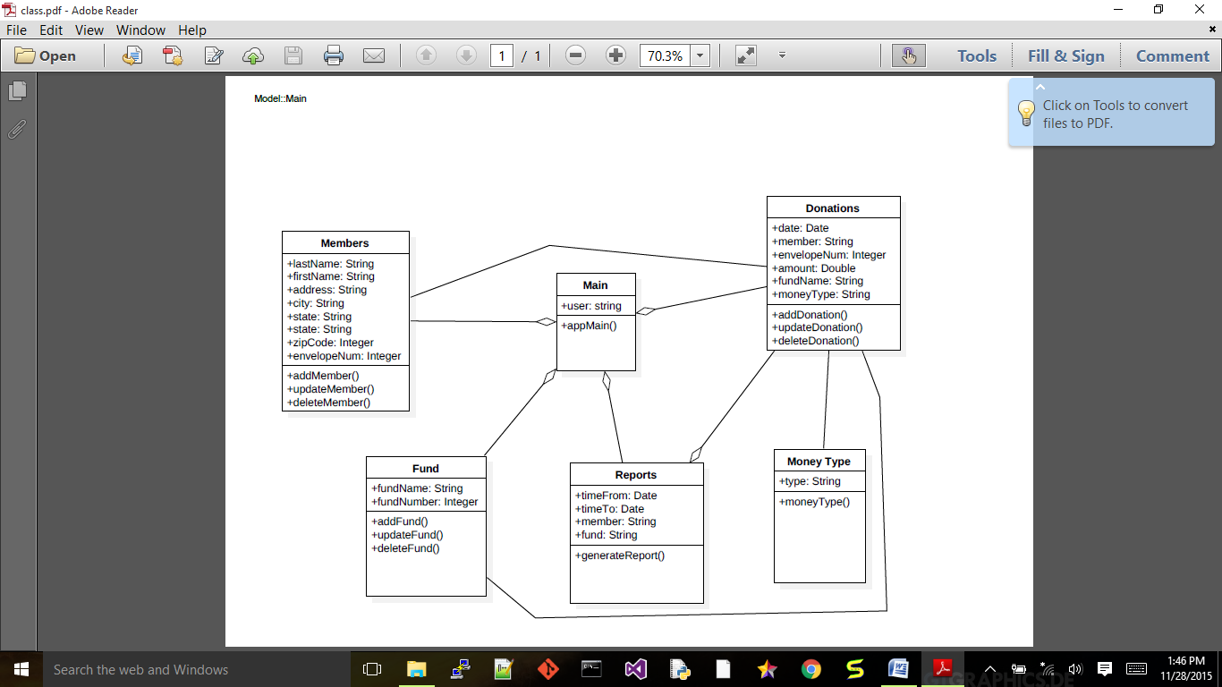

Fig 3: Class diagram

3.2 User interface specifications

The application is to have the following requirement for smooth functioning. Interaction instruments are: Mouse, keyboard, touch screen and web browser.

3.3 Non-Functional Requirements: Management

Proper usage of resources is needed. The work force for developing the project is very important, with less time and limited people to work on the project, these are the tight constraints to handle and finish the project.
The management of the project is a very difficult job to be done. It involves the proper planning of resources, management and co-ordinations between stake holders.

3.3.1 Technical

Microsoft Visual Studio 2013 is a very powerful development tool used for fast and robust application development.
The Microsoft SQL server is used as the backend for data storing, retrieving, updating and other functions of the application.

3.3.2 Performance

The software application developed is a web based application. The end system should have good hardware and software configuration for smooth functioning of the application.

3.3.3 Security

Records related to money are handled by the application which is being developed. Security features are given high importance with proper verification and validation techniques.
3.4 System Evolution/Maintenance

The software wears out and performs slow due to various constraints. It requires maintenance in day to day life for the application to work smoothly, correctly, and like its first use. The application being developed allows for easy maintenance, updating and enhancement.

4. Other Deliverables Required

The deliverables for this project are the software code document, user manual, specification document, testing document, acceptance document, use cases diagrams, and UML diagrams.

5. Glossary

GUI : Graphical User Interface.
SQL : Structured Query Language.
UML: Unified Modeling Language.

6. References

[1]. Larman,C., Applying UML and Patterns: Introduction to Object-Oriented

Analysis and Design and Iterative Development, 3rd edition(October 2004).

[2]. Sommerville, I., Software Engineering 9th edition book, NY, Pearson, 2011.

